STEP BY STEP TUTORIAL
HOW TO USE THE SOFTWARE

Click on the following URL:
http://www.radioforecastnetwork.net/cgi-bin/rfn/user/feeds.cgi?c=login
  - This will bring you to the Log-in page. Please read the Frequently Asked Questions.
  - Operations Manager and Chief Meteorologist, JIM Rinaldi, WILL PROVIDE A LOGIN FOR THIS PAGE. (Jim is the Go-To Guy for all questions regarding forecasts, assignments etc.)
  - Once logged-in, you will be in front of your first weather assignment of the day.

FOUR things to do before beginning your session:
- POINTS:
Make sure you have tallied the number of points you accrued the day before. You will need to keep track of your own points for billing. You are contract labor and must invoice us every week.
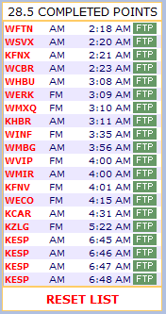
- RESET THE LIST: GREEN “FTP” buttons will turn RED.
Before you click “RESET”, you will see FTP Buttons that are all GREEN with a Point Total at the top of the list. This means that the list was completed YESTERDAY.

- Go to the bottom of the list, click on the RESET Button, when prompted, say yes, and you will notice the Point Total will go away, and the FTP Buttons will now be RED. As you complete each forecast, the station call letters will move to the bottom of the list, and the RED FTP Button will turn GREEN. A Point Total will start to accrue.
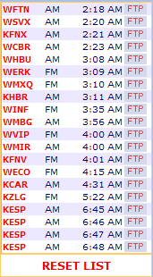
- Here is what it looks like as you are doing a list. The green ones have been completed, the red have not. In the example below, I know I have to do KRKI next.
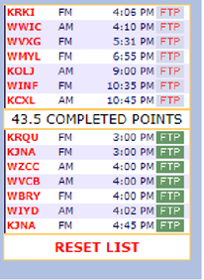

- DELETE YESTERDAY’S PREVIOUSLY RECORDED FILES:
In YOUR editing software, on YOUR computer, make sure that you have deleted ALL weathercasts recorded the previous day. Today, you will be recording and naming (with the same file name) the updated forecasts for each of your respective stations. If you skip this step, you run the risk of uploading yesterday’s weathercasts by mistake.

Recording your forecasts:

Click on the call letters of the first forecast on the list. When the page opens, in the upper left-hand margin, you will see a Box that displays ONE of TWO things:
- The station uses an audio downloader to pull the mp3 file from our server into their automation.
- The station manually downloads the mp3 file and physically loads it into their automation.

Regardless of whether the station uses Option A or Option B, you simply record JUST the weathercast, then edit, trim & crop the file to the exact length requested by the station.
Option “A”:
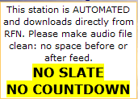
Option “B”:
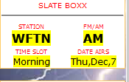
The reason why these options are highlighted: There was a time in the early days of digital downloading, some stations needed an audio message to the downloader “in front of” the actual WxCast to be aired so the downloader knew that he or she was downloading the correct WxCast. The Dark Ages of radio lingered for years. RFN does not offer that service any longer.

The FEED INFO Box is the most important on the page
It is in the middle of the left-hand column and contains all the information as to what the feed gets:

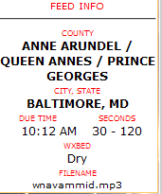
“County, City, and State” …..indicates the geographic location of the station)
“DUE TIME” …..is your deadline to upload the file in CENTRAL TIME. You can record up to 9 hours in advance from central time without an error. The caveat to that would be doing midday or afternoon feeds before midnight. In other words. If a midday feed is due at 7:00AM, you could not do it at 11:00PM even though is 8 hours. If a morning feed is due at 7:00AM, you could upload at 11:00PM.
On the other end, there is a minimum of 45 minutes buffer before the feed is late for the station and in a lot of cases, it’s even more. So if you’re running 10 or 15 minutes behind and you get an error message, don’t panic. If you’re coming up on the 45 minute threshold of think you’ll miss it, let Jim know
“Seconds” …..is the minimum and maximum length of the forecast (which is two numbers, the shortest and longest length of the weathercast ( stay somewhere in between these two numbers)
“Seconds” …..is the minimum and maximum length of the forecast (which is two numbers, the shortest and longest length of the weathercast ( stay somewhere in between these two numbers) This time is for your actual forecast--- not the entire length of the file you may be uploading. the SLATE doesn’t count as part of the time.
“WXBED” ….. will either display “Dry” or “Music” If it displays “Music” you will find the “music bed” or “jingle” at the link on this tutorial page.
“FILENAME” …..is to be used for the finished forecast to upload. There’s a better place to get that, which will be explained later.

“FORECASTS 1-2-3-4”
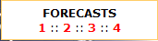
#1 is the NWS forecast, which is the default forecast which will come up on its own. If it doesn’t, which rarely happens, you can click on #2--- the WeatherBug forecast is for the same geographic location. It is a graphics forecast only unless you manually click the daypart. #3 is Weatherforyou. It is similar to the NWS format with a graphic and text forecast and #4 is currently a dead link for a lot of stations. For some of the newer ones, it is myforecast.com with a graphic and text output

Below that, we’re back to the list….

Random Notes:
Two to Three climates in one forecast.
Occasionally, you may have a forecast page come up that has TWO Windows in the middle of the page. One region is on top, one on the bottom. It may be two regions, it may be a regular forecast and a marine forecast. There are two separate scroll bars. Any special instructions should be in the NOTES Section in the upper right-hand corner. We have two or three stations that have THREE forecast areas to cover, and again, that’s covered in the NOTES Section. The time of the feed is TOTAL for both regions combined.
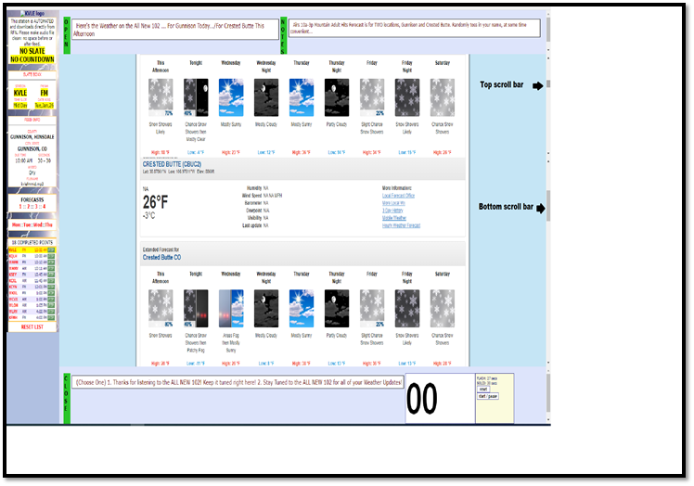
Should you wait until one forecast is uploaded to move to the next?
Once you have started to upload a forecast from the FTP Page, you can go back to the Forecast list, and start on the next forecast. The two pages are separate, and don’t affect each other---UNLESS, on slower uploads, for some reason, you try to upload another forecast before the last one has been fully uploaded. If the first one isn’t finished, when you go the upload the second forecast, it will negate the upload in progress.
How we deal with stations that want forecasts a day or two in advance because of holidays:
In the left-hand margin, at the top of the page, below the original RFN Logo, will be clickable links to FOUR days. The first day displayed in the box is a list of “yesterday’s” feeds. The second day in the box is “today”—the current day your forecasts are to be uploaded. The next TWO days displayed are two days’ feeds in the future. (If today is Thursday you will see Wed::Thu::Fri::Sat)

This will only come into play if you are recording forecasts at night for the next day, at which point you will want to click on the next day for the proper Information. We do have several stations that have a different Sponsor for the Open/Close for every day part of every day. So, if you are on the wrong day, you’ll have the wrong information. Otherwise, the software will default to the current day. This is mainly used for holidays.

The Forecast page at a glance
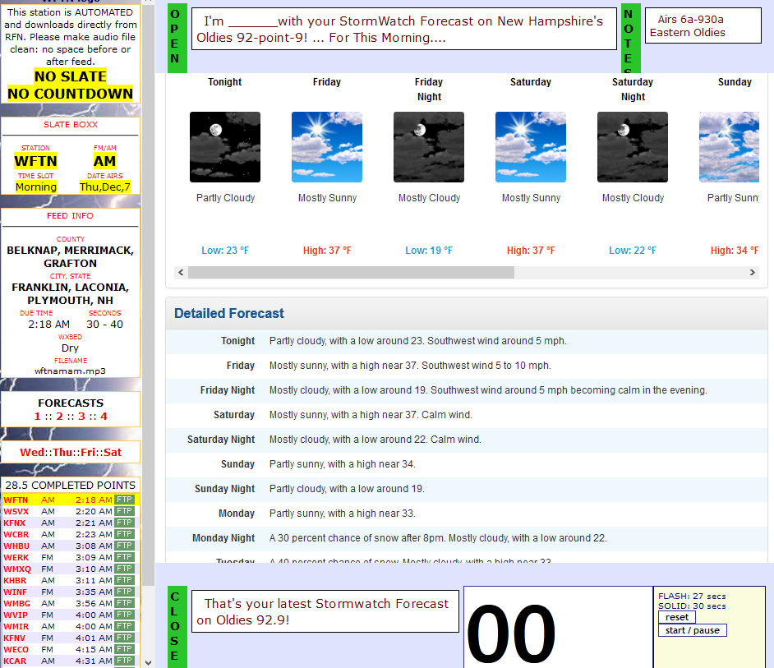
As for the Forecast, it’s relatively straightforward: The OPEN is at the TOP, the CLOSE is at the BOTTOM, the forecast is in the middle of the page. There is a clock in the lower right-hand corner, which makes it a lot easier to keep your time, and can really help your efficiency, as you know where you are during your forecast….
When you’ve recorded your forecast, edited it, trimmed it to the proper time and have it ready for uploading, (I compress and normalize everything personally) you will click on the FTP button at the end of the line of the forecast you are doing. You can click on any other RED FTP button and nothing will happen. ONLY the forecast page FTP button that is open will work--- a safeguard to keep from inadvertently sending a station the wrong forecast. GREEN FTP Buttons, on the other hand, can always be activated….so watch out for that.
When you’ve clicked on the FTP Button, a board will pop up asking for a username and password. The username is “upload” and the password is “21stcentury”. An FTP Page will display with the Filename you need to assign your forecast. I have a folder uniquely entitled “Forecast” that I use. Copy and Paste the Filename into your “save line” in your recording software, save it to the Folder you’ve set-up. On the FTP Page, you can browse to where you’ve saved the forecast, click it into the box, and send it up. When you’ve sent it, you will get a Message that says, “ON TIME, Good Job.” It might say “Too Late, Accepted” or “Too Late, Rejected.” Regardless of what the message says, we have set the software to “override” these error messages. We simply want to know “THAT” they are being uploaded. In other words, if you get a message, the forecast has been delivered to the FTP site. The ONE EXCEPTION to this is if you get a message that says, “I’m sorry, we’re all full up and not taking any more business today” ---or something like that. If you see that, Call Rod immediately, as this means the Server is full, and we must get our Programmer to fix it.
You can check it yourself, which people like to do, especially when they first start, by going to www.radioforecastnetwork.com and Clicking on “Our Network”, finding and clicking on the state, then click the call letters and click on the feed to listen to your forecast.

